Seminar 2

1. Prove that:

a) 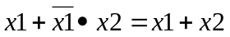
b) 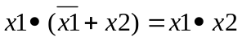

2. Verify the following identities:

a) 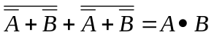
b)
c)

3. Show that all the switching functions can be realized using only NAND gates.

4. Same problem as problem 3, with NOR gates.

5. Prove that:

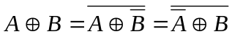

6. Consider the AND-OR-INVERT circuit, composed of a solid block of gates as shown in the Figure below:

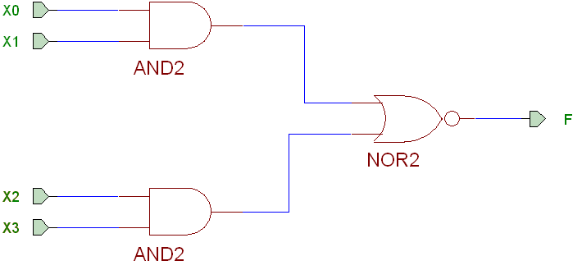

- Realize the NOT function using an AND-OR-INVERT circuit.
- Realize the XOR function using 2 (two) AND-OR-INVERT circuits.

Indication: Use problem 5.

7. Express the function: f = p₃ + p₂₁ + p₂₄ + p₂₉ + p₃₀ by:
a) Truth table
b) Disjunctive canonical form
c) Karnaugh map.
8. Express the function: 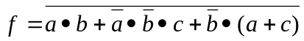 using only NOR gates.

9. Consider the function:. Determine the Disjunctive canonical form and the Karnaugh map.

10. Minimize the function: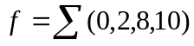.

11. Minimize the Boolean functions associated to a 7-segments BCD Decoder.
